Advanced Smart Mobile

Pronckutė, Edita E.

Fontys UAS

Advanced Smart Mobile

UX analysis of EnWB mobility+ mobile app

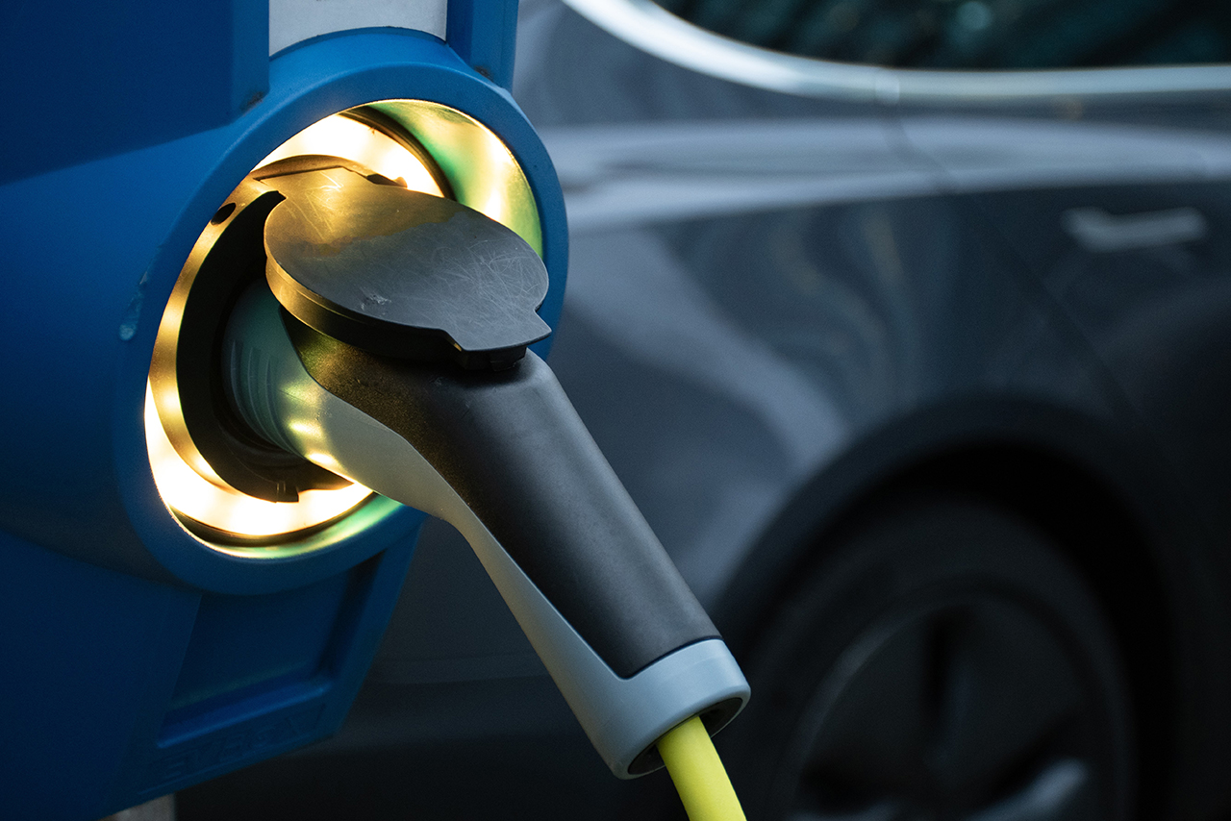

Contents

About 2

The 5 dimensions of Interaction Design 3

7 Factors Describing User Experience 6

Don Norman's Principles of Interaction Design 7

Dieter Rams 10 Principles of “Good Design” 8

References 10

# About

EnBW mobility+ is the smart all-in-one solution for an Electric Vehicle (EV) copilot offers three functions in one app:

* Searching charging stations nearby
* Charging and payment
* Taking EVs for virtual test drives

**Charging Stations Locator**

The main use of the application is the nearest charging station locator. There is a widespread network of EnBW chargers and roaming partners in various European countries (Germany, Austria, Switzerland, France, Italy, Netherlands etc.). In addition, users can save or mark charging stations, see their availability and conveniently navigate to them using google map integration.

**Charging and Payment**

EnBW mobility+ app enables users to conveniently start the charging process and even pay directly via your smartphone. Users can monitor their charging progress and stop the charging once they have enough energy. Moreover, the charging history and costs can be reviewed and checked at any time.

**Test driving any EV**

For the users interested in a new EV, there is an option to virtually test drive an EV of their liking. They can choose from a comprehensive pool of all currently available EVs to simulate a preferred EV drive with their conventional car make in-depth comparisons of different vehicles and how they match their profile.

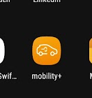  
For the UX analysis of the application several methods/frameworks acknowledged in design community have been chosen. The report is supported with snippets from the application using Android device to help illustrate the analysis and improve its readability.  
The focus is on EV charging and navigation aspects of the app.

Figure . App icon

# The 5 dimensions of Interaction Design

The dimensions help understand what user interaction the application involves. Gillian Crampton Smith first introduced the concept of an interaction design language with four dimensions, later Kevin Silver added the fifth. It is a frequent used approach to evaluate or analyze the design of various products.

**1D: Words**

Every major icon and button have a small text underneath or next to it. It helps users to understand what the icon or a button means and does. The text is kept small and precise. It is helpful and not   
 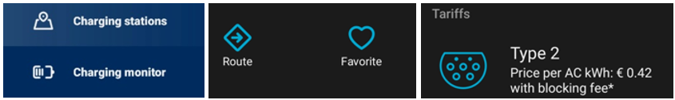 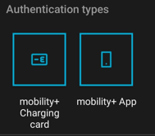

Figure . Examples of icons with text explanations.

Intrusive (Figure 2). There are a few that do not have an explanation yet but by the time user reaches it, it was already introduced to them. Thus, the text is helping a user learn how to navigate the application but is omitted where it is not needed or is repetitive.



Figure . Icons without explanation but user already saw them in previous views that were required to get to this one.

**2D: Visual representations**

As mentioned above some icons complement the text and vice versa. Icons like a download document, settings and FAQ are very clear and may not require addition text, though it is probably added to maintain the fluent design of the application.



Figure . Icon examples, clear, supplementary and not so clear.

In the middle image history and tariffs would not be clear without the text, however, the image on the right orange euro icon looks like a button, but it is not. Perhaps, it marks that the invoice has been paid, though a user should not be guessing its meaning.

**3D: Physical objects or space**

The application is mostly used in the car, right before the drive or even during it. There is one very convenient option that enables a user to set up the navigation to the chosen charging station by directly passing its coordinates to google maps (icon marked yellow in the image below). Google maps can be connected to the main car screen via Android Auto, which rather automates the process even more.

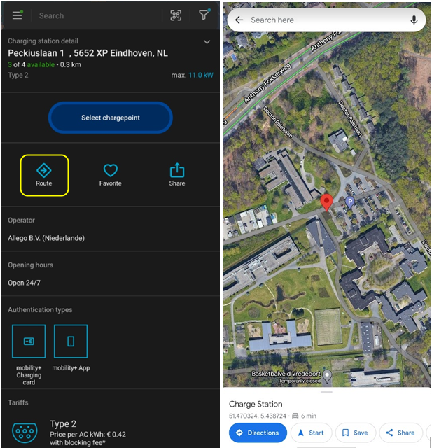

Figure . Route button opens google maps with the coordinates to the chosen charging station.

This is a good design as when a user is driving minimal interaction is what they need. What would make it even more convenient if the app could be used directly with Android Auto.

In addition, the application tries to mimic natural navigation gestures. For instance, swiping from left will go back one screen in Android while it does not on apple device, as it is not a natural gesture.

**4D: Time**

Application is used constantly on the long trips (depending on the battery capacity of the EV and frequency of stops). During average trips (within country) a user might need it once or twice for a limited time only. It is extremely reliable and important, however, it should become irrelevant in the future as more and more stations will be present and marked appropriately across the globe.

The application is meant to be used in the car, thus the interaction should be rather minimal not to distract the driver. There are no sounds in the application, which is a good thing for this particular case.

Opening an application as well as zooming in and out of the map has a nice quick animation effect that gives a smoother feeling of interaction with an application.

Figure . Animation examples of the mobility+ application

**5D: Behavior**

The way user interacts with the application is quite intuitive. The gestures are familiar as well as most icons (i.e., hamburger menu). The whole interaction can be split into three sections: before the drive, during and after. First, user can plan the trip, highlight favorite destination and calculate expected duration. During the drive, user may want to check if the charger is still available and adjust the destination if needed. After the trip a user may check the invoice and the charging costs. The application really fits into the natural user behavior around EV charging and navigation during the trip.

# 7 Factors Describing User Experience

**Conclusion**

The success of a product depends on more than utility and usability alone. Products which are usable, useful, findable, accessible, credible, valuable and desirable are much more likely to succeed in the market place. ANWB mobility+ has some strong points for each of the factors, though there are areas for improvement too, such as limited accessibility.

# Don Norman's Principles of Interaction Design

# Dieter Rams 10 Principles of “Good Design”

**Developed by a German industrial designer that worked with Braun’s consumer products. Dieter questioned his own designs and developed the 10 principles or commandments of good design that are still relevant today.**

**1. Good design is innovative.**

The possibilities for innovation are not, by any means, exhausted. Technological development is always offering new opportunities for innovative design. But innovative design always develops in tandem with innovative technology, and can never be an end in itself.

**2. Good design makes a product useful.**

A product is bought to be used. It has to satisfy certain criteria, not only functional, but also psychological and aesthetic. Good design emphasises the usefulness of a product whilst disregarding anything that could possibly detract from it.

**3. Good design is aesthetic.**

The aesthetic quality of a product is integral to its usefulness because products we use every day affect our person and our well-being. But only well-executed objects can be beautiful.

**4. Good design makes a product understandable.**

It clarifies the product’s structure. Better still, it can make the product talk. At best, it is self-explanatory.

**5. Good design is unobtrusive.**

Products fulfilling a purpose are like tools. They are neither decorative objects nor works of art. Their design should therefore be both neutral and restrained, to leave room for the user’s self-expression.

**6. Good design is honest.**

It does not make a product more innovative, powerful or valuable than it really is. It does not attempt to manipulate the consumer with promises that cannot be kept.

**7. Good design is long-lasting.**

It avoids being fashionable and therefore never appears antiquated. Unlike fashionable design, it lasts many years – even in today’s throwaway society.

**8. Good design is thorough down to the last detail.**

Nothing must be arbitrary or left to chance. Care and accuracy in the design process show respect towards the consumer.

**9. Good design is environmentally friendly.**

Design makes an important contribution to the preservation of the environment. It conserves resources and minimises physical and visual pollution throughout the lifecycle of the product.

**10. Good design is as little design as possible.**

Less, but better – because it concentrates on the essential aspects, and the products are not burdened with non-essentials. Back to purity, back to simplicity.

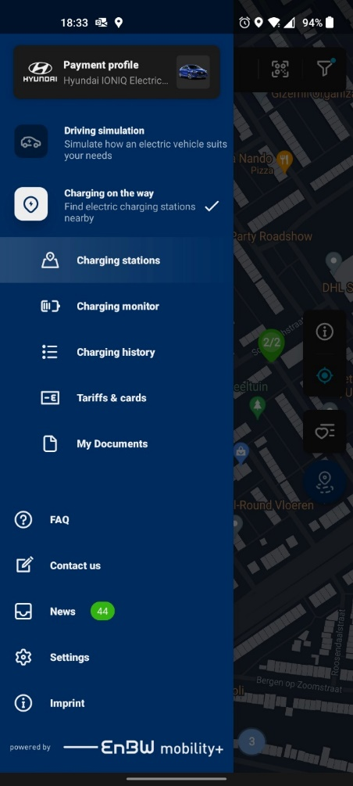 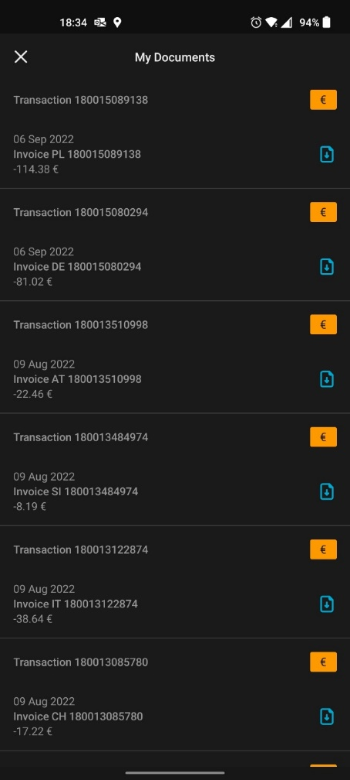 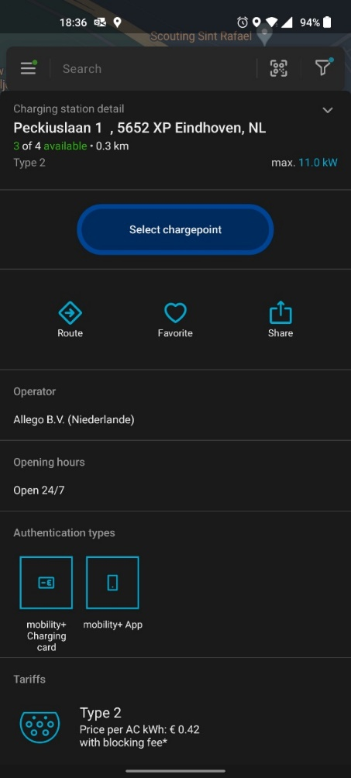

# References

<https://www.interaction-design.org/literature/article/what-is-interaction-design>

<https://uxplanet.org/interaction-design-a-guide-for-beginners-32ff2364b53f>

<https://www.interaction-design.org/literature/article/the-7-factors-that-influence-user-experience>

<https://www.sachinrekhi.com/don-norman-principles-of-interaction-design>

<https://www.educative.io/answers/what-are-normans-design-principles>

<https://www.aamirdesign.com/blog/dieter-rams-10-principles-of-good-design>

<https://www.interaction-design.org/literature/article/dieter-rams-10-timeless-commandments-for-good-design>